 **BAHRIA UNIVERSITY (KARACHI CAMPUS)**

**ASSGINMENT#3 (OEL-I) - SPRING 2020**

# DATABASE MANAGEMENT SYSTEM (CSL-220)

Class: **BSE 4(B)**

Course Instructor: **Engr. Bushra Fazal Submission Deadline: 25th April, 2020**

Lab Instructor: **Engr. Saniya Sarim** Max Marks: 15

Student Name: **Syed Ali Abbas** Enrollment No**. 02-131180-070**

**[Original Question 2]**

**Question 1: [CLO2,15.0 Marks]**

A company database needs to store information about employees (identified by ssn, with salary and phone as attributes), departments (identified by dno, with dname and budget as attributes), and children of employees (with name and age as attributes).

Employees work in departments; each department is managed by an employee; a child must be identified uniquely by name when the parent (who is an employee; assume that only one parent works for the company) is known. We are not interested in information about a child once the parent leaves the company.

1. **Draw an ER diagram that captures this information**.

**Answer**

* It is given in the scenario that Employee has SNN, Salary and Phone attributes. Where SNN is a primary key and is underlined as shown below:

Employees

* Department has attributes dno, dname and budget. Where dno is primary key as shown below:

Departments

* Children has attributes name and Age as shown below. **Child is a weak entity because its attributes does not uniquely define the entity.** Since child does not have unique primary key attribute. So we will introduce **discriminator** here. **Discriminator** is a set of attribute which makes distinction in entity. Discriminator is shown by an attribute with dotted line under it as shown below:

Child

**Note:**

Primary key of weak entity is made by using the primary key of strong entity on which it depends plus the discriminator.

**Complete ER Diagram:**

Works_in

Department

Employees

Managed_by

<

Depends

^

Child

1. **Design a database schema with proper constraints.**

**Create Database:**

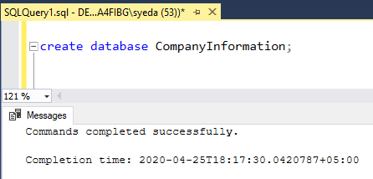

**Create Employee Table:**

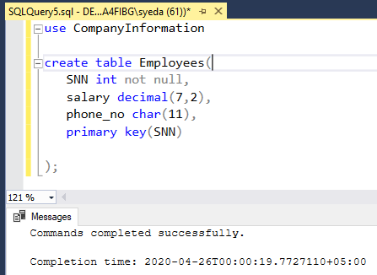

**Create Department Table:**

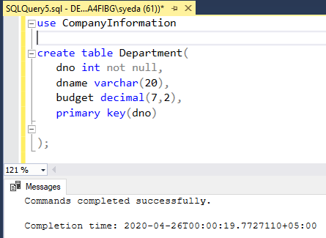

**Create Child Table:**

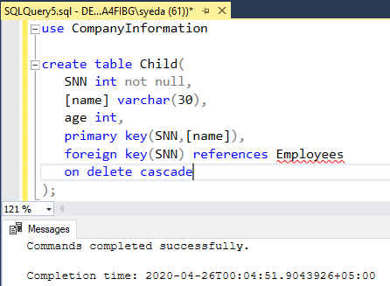

Now on observing (**works_in)** we can see that there is many to many relation because an employee can work in many departments and similarly a department can have many employees working in it.

But it only contains one manager who can manage the department.

**Create table works_in:**

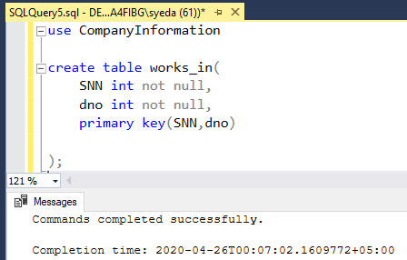

**Create Table Managed_by:**

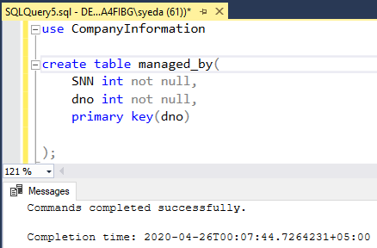

1. Insert values in each table as given in the file.
2. **Employees SSN**:1,2,3,4,5,6,7,8,9,10

**Salary:**21000,22000,25000,23000,24000,29000,28000,27000,26000,30000,

**PhoneNo:**02144735,02144735,0214447535,0217533455,02137643,0214536,021475646,02148386,021284732,021284635

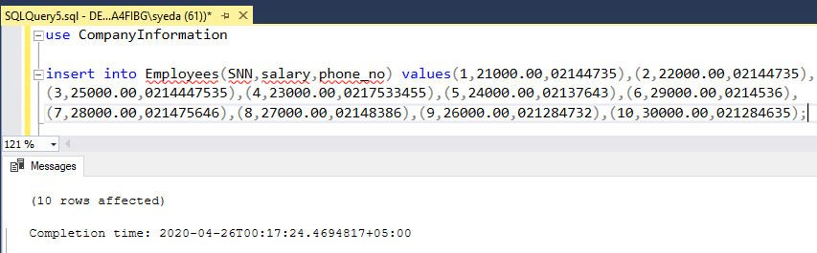

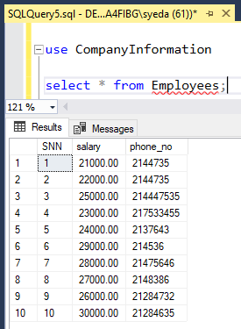

1. **dno:**01,02,03,04,05,06,07,08,09,10

**dname:**SE,CE,BBA,MEDIA,DATASCIENCE,ManagementScience,LLB,CS,Accounting, Finance

**budget:**50000,45000,55000,60000,40000,60000,30000,35000,38000,39000

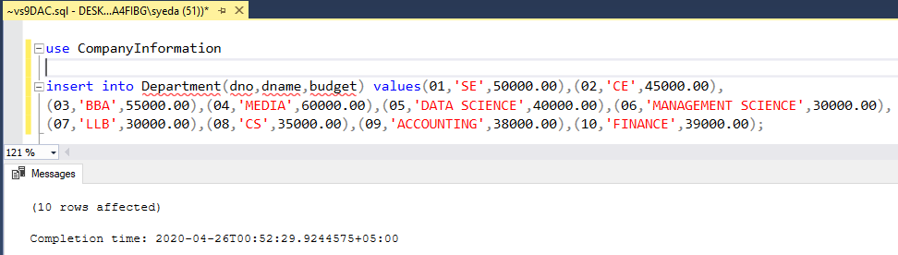

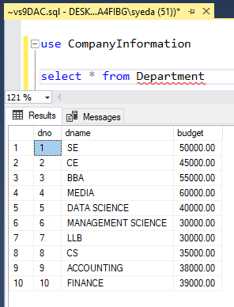

1. **ChildrenName:**John,Ali,Kashif,Ahsan,Munir,Taha,Hamza,faizan,Yousuf,Faiz

**Age:**20,22,23,20,19,15,13,16,18,16

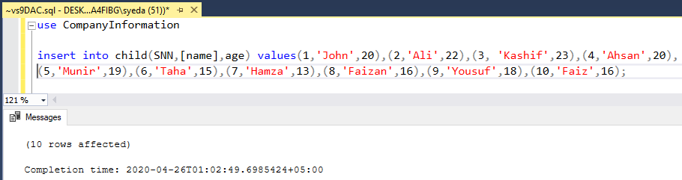

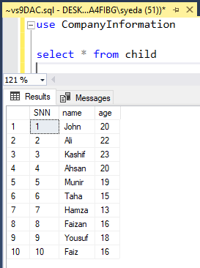

1. Create reports that should display the following information:

* list of all the employees working in each department.

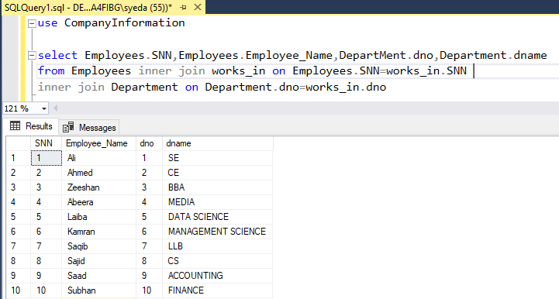

* employee that has lowest salary.

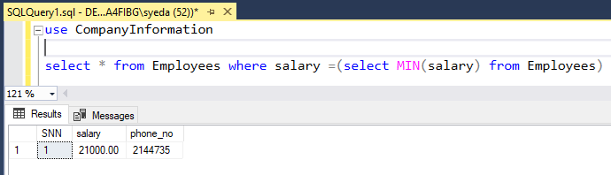

* employees with the name and age of their children.

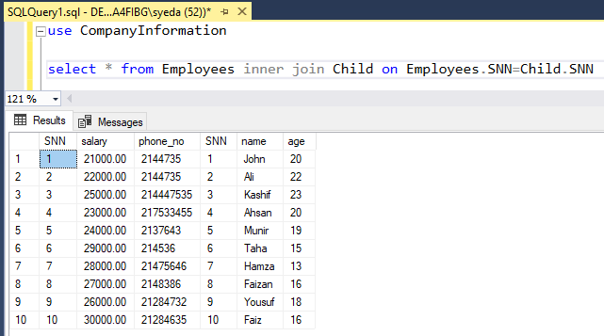

* Total number of employees working in each department.

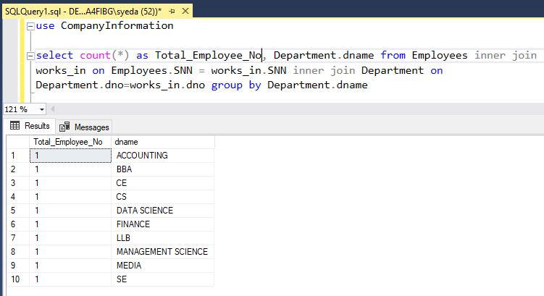

**Note:**

After adding one more Employee for Media Department We can see the change in Total count of employees working in department as shown below:

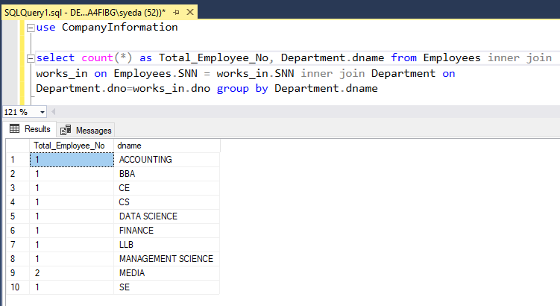

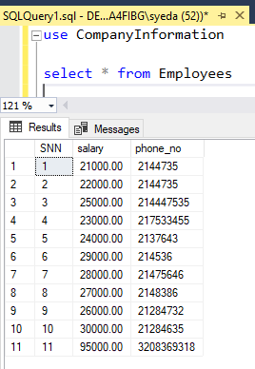

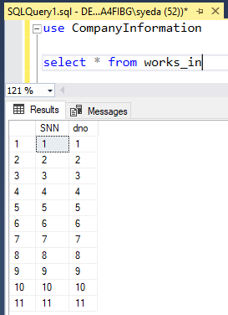 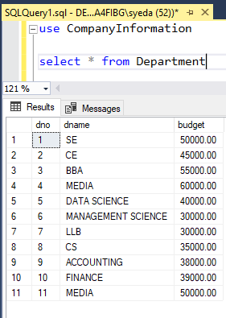

* name of the employee working in department 03.

According to the requirement first of all altering the Employee table and introducing another Employee_Name column in it as shown below :

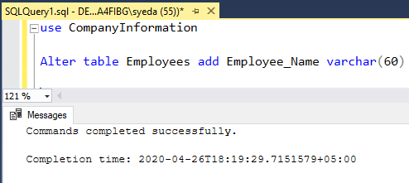

Now updating all the records and adding Employee_Name in it.

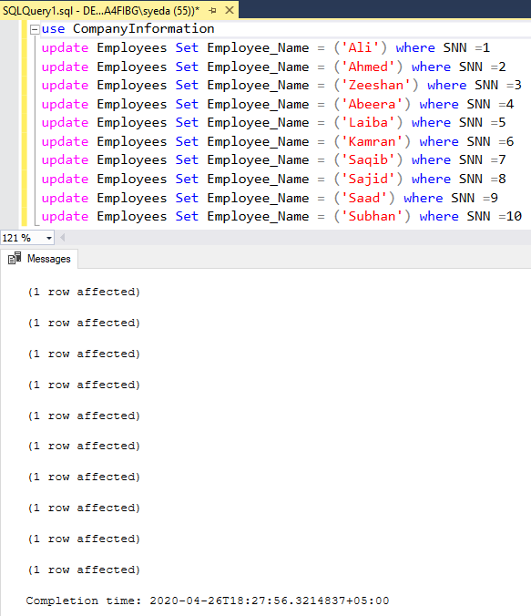

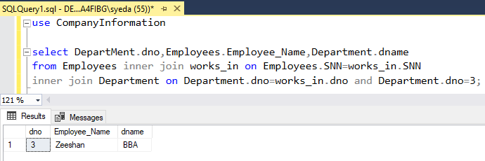

* employees with their children and department names.

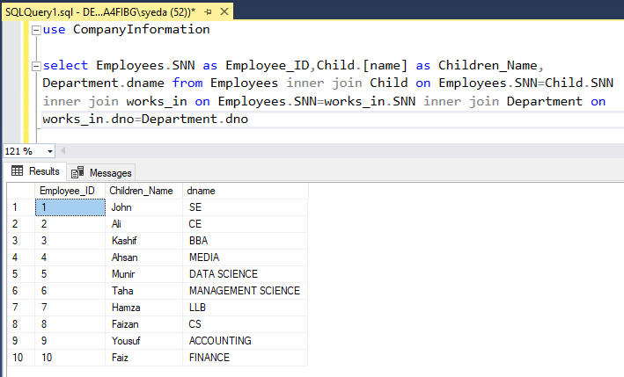

1. Devise a technique that could make search faster in employees by its salary.

**Note:**

We had created non clustered index on salary column because SNN is primary key and primary key already has clustered index and there can be only one clustered index in table but can have multiple non clustered indexes in a table.

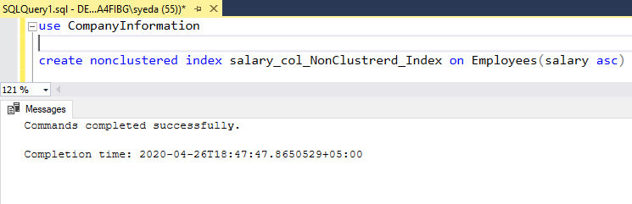

**Index Created**



To create clustered index we will have to remove the primary key constraints from SNN of Employee table as shown below:

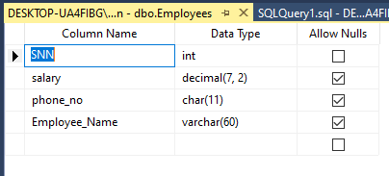

**Creating clustered index here:**

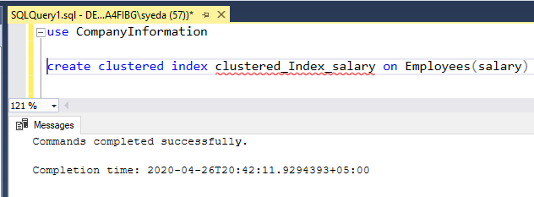



We can see that the records are sorted according to salary amount while the SNN is disordered:

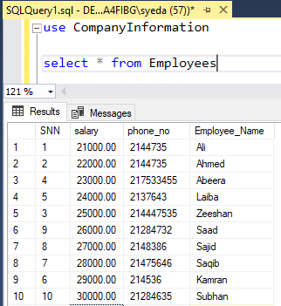

Since clustered index is more fast so we can easily access data record using salary of an employee